Numbers 32 Outside the promise land

Read Numbers 32

The request (Verses 1-5)

Can you briefly describe the request made? (Use the map provided, indicate the place of settlement for the 2½ tribes)

Who made the request?

What do you think are the reasons behind the request?

Would you consider the request reasonable?

Now consider the historical background.
Read Numbers 26:53-56, do you find anything uncomfortable with the request made by the 2 and half tribes?

Read also Exodus 12:29 on the promise from God. Cross reference that to Numbers 34:12, share your observations with your group.

Moses’ reaction (Verses 6-15)

What is Moses’ response?

Can you list Moses’ objections?
1)

2)

3)

Look back at the example that Moses’ cited (Numbers 13:31-33), do you think Moses’ fear is justified? (If you have the time, look for parallel usages of similar terms in both passages)

Moses in verses 9-13 gave us a small sermon on how history is used to interpret present choices as well as the motivation for their (our) actions. Can you give the motivation and the way Moses apply history:

Motivation (v11):

Application of history:
What was the historical incident in view?

First generation decision and outcome?

What lesson to be learnt?

Counter proposal (Verses 16-19)

Hearing Moses’ anger did not changed the end goal of the 2½ tribes. It did of course caused them to come up with amendments to their plan. Can you identify each of the proposal to address Moses’ concerns?

1)

2)

3)

(A small exercise)

Count the number of able, fighting man from the 2½ tribes

From Reuben (Numbers 26:7) :
From Gad (Numbers 26: 18) :
From Manasseh (Numbers 26:34) :
Total (take ½ from Manasseh) :

Now look at the record in Joshua 4:13, how many actually crossed over and fought with the rest of the tribes:

Any thoughts on this commitment (looking at the assessment of Joshua in Joshua 22:2 compared to Moses’ statements in verses 21, 27, 29)?

Moses’ second response (verses 20-27)

Give your assessment on Moses’ responses to the counter-proposal.

In verse 23 we have the warning from Moses, “but if you do not do so, then take note, you have sinned against the Lord, and be sure your sins will find you out.”

From the text, what is the main issue that Moses is warning the 2½ tribes about?

From a longer time horizon, there perhaps is a different kind of issue being looked at [let’s take a historical perspective]

- Consider the story in Joshua 22 (especially from verses 10ff).
  - What happened?
  - Why do you think there is this problem?
- Read 1 Chronicles 5:25-26
  - In verse 25 there was the assessment of the religious life of the trans-Jordan tribes. What was it? Why do you think it developed this way?
  - In verse 26 something terrible happened, what is it? These tribes have the dubious honor of being the first people of Israel being led to captivity.
- Read the account in Matthew 8:28-34. This is a place in Gergesenes (Gergesa/Gadarenes). I have attached a map showing Palestine in the time of Jesus’ ministry. If you compare to the settlement map of Reuben/Gad/Manasseh, you will notice that this is the former trans-Jordan site. Consider this was the settlement for Reuben/Gad/Manasseh, do you find the scene in the account in Matthew 8:28-34 surprising? Discuss (hint: swine).
- Finally think about the split between the 2 halves of the tribe of Manasseh. Do you find it natural?

Practical Arrangements (verses 28-42)

Why does Moses repeat the instructions he gives the tribes to Eleazar (Verse 28-30)?

What does this teaches us about our pledges and commitments?

Summary and conclusions

The text for chapter 32 seems to present no direct assessment on whether the full settlement for Reuben/Gad/Manasseh was with or without the approval and blessings of God. It has therefore left many commentators split on the central theme for this chapter. The following summary and conclusion is one view and is my view:

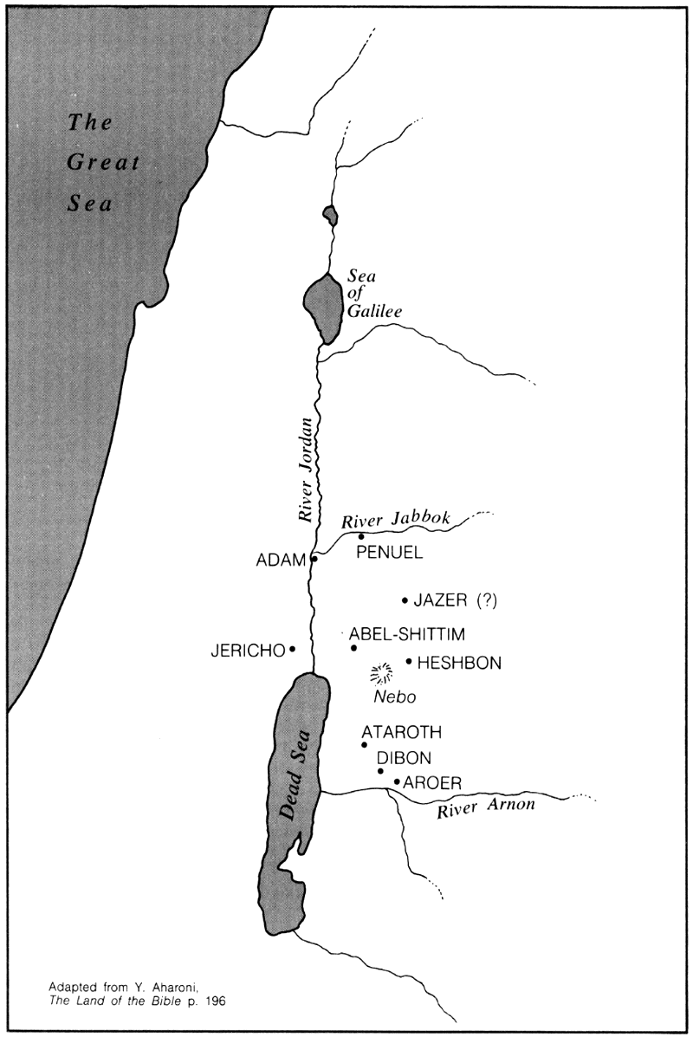
1 Map of the trans-Jordan area in the time of Exodus

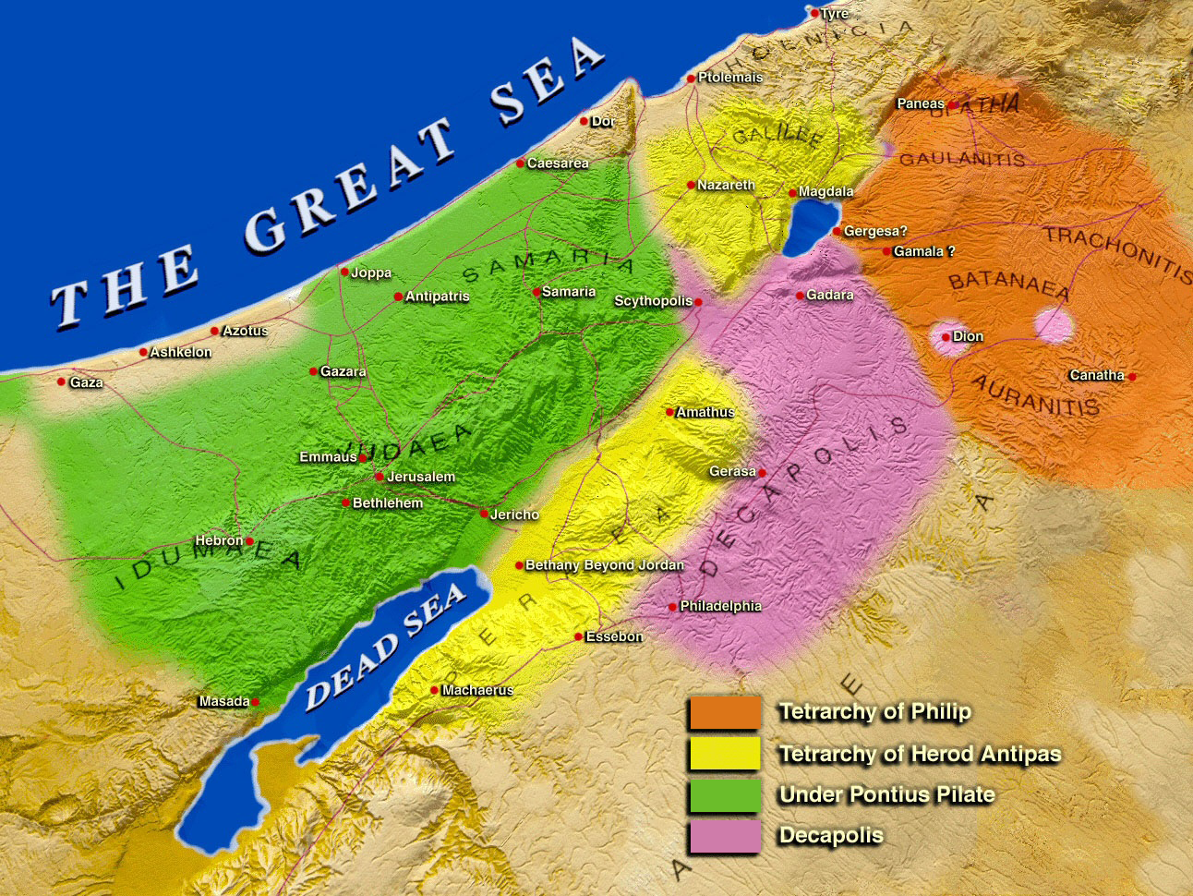
2 Palestine during the ministry of Jesus

